Optimal Capital Structure

Learning Outcomes

After completing this module, students will be able to:

- Illustrate the interrelationship of business risk and financial risk in determining a firm's optimal capital structure.
- Calculate the degree of operating, financial, and combined leverage.
- Explain the MM without taxes, MM with taxes, static trade-off, pecking order, financial slack, and unused borrowing capacity, agency, signaling, and market timing theories for determining capital structure.
- Assess the capital structure policy of an organization using the minimizing WACC, industry average ratio, and worst-case scenario methods.
- Explain other practical considerations that influence the optimal capital structure decision.
- Determine the effect that a change in capital structure has on a firm's leveraged beta by combining the MM with taxes and CAPM formulas.
- Discuss why most firms employ a dynamic trade-off model when determining optimal capital structure with considerable variation around the target.

Introduction

Financial professionals often talk about the “magic” of financial leverage. How this works is that companies borrow money at low rates from financial institutions or by issuing bonds directly to investors. These funds are then reinvested in the company, where they normally earn higher returns because of the greater risk of operating a business. The firm pays taxes on the difference and keeps what remains. Another name for this process is “putting other people’s money to work for you.”

It sounds simple, but companies must be very careful to use financial leverage in moderation. High leverage means high debt servicing costs, which include interest and principal repayments. When the economy is doing well, companies can generally meet these obligations because cash flows from operations are high. If a major economic slowdown occurs and they tend to occur unexpectedly, then a company may struggle with its debt servicing. If it cannot meet its obligations, it may have to declare bankruptcy and be forced to either reorganize or liquidate. Regardless, shareholders often lose their investment.

Managers must be able to determine a company’s optimal capital structure. This is the level of borrowing that best balances the benefits of financial leverage with the risk of bankruptcy. The general rule is a company should only borrow what it can pay back in a serious downturn. If they borrow more, they put the business at risk.

1.1 | Optimal Capital Structure Basics

Capital structure is the ratio of permanent debt financing (D) to permanent equity financing (E) which are both used to finance a company’s long-term assets (B) and long-term net working capital (A minus C at the seasonal low). Permanent debt financing (D) does not include temporary financing (F) as this should only be used to fund the seasonal build-up of net working capital. Capital structure indicates how much financial leverage a firm is using.

Exhibit 1: Maturity Matching
Seasonal Low
Seasonal High

A – Current assets
B – Long-term assets
C – Current liabilities
D – Permanent debt financing
E – Permanent equity financing
A minus C – Net working capital (NWC)
F – Temporary financing

Using financial leverage increases a firm’s share price or return on equity (ROE), but only to a certain point. At some level, the increased returns from financial leverage or substituting cheaper debt for more expensive equity will be offset by a higher cost of debt (k_{d}), cost of preferred shares (k_{p}), and cost of common equity (k_{c}) due to greater financial distress or bankruptcy costs. These include:

Direct bankruptcy costs. The legal and accounting expenses related to going bankrupt and the losses companies incur selling their assets, especially illiquid assets like specialized equipment or factories, at “fire-sale” prices that are well below fair market value.

Indirect bankruptcy costs. Experiencing financial distress before going bankrupt leads to behaviours that are not in the shareholders’ best interests. Senior managers become pre-occupied with avoiding bankruptcy instead of operating the business. CEOs are more willing to “bet the company” on risky ventures as they have nothing to lose. Investors lose interest as the firm’s shares decline in value. Lenders impose stricter loan conditions causing monitoring costs to rise, charge higher interest rates, or refuse to finance firms entirely. A company’s bond rating is reduced. Merger and acquisition partners lose interest. Important suppliers refuse to grant credit and place the company on “cash and carry.” Valuable employees leave to find more secure employment elsewhere. Existing and potential customers do not buy products because they are worried about a stable source of supply and a lack of support if the firm goes bankrupt. Projects with a positive net present value (NPV) are often ignored due to a lack of cash and debt financing.

Understanding Optimal Capital Structure

The exhibit below explains why it pays firms to borrow and the concept of optimal capital structure.

Exhibit 2: Using Financial Leverage
Assets = CAD 100
Operating income = CAD 10
Cost of borrowing = 8.0%
Tax rate = 25.0%
Debt ratio = 0.0%
Debt ratio = 50.0%
Debt ratio = 90.0%
A
E
A
L
E

A
L
E

Operating return on assets | = 10 ÷ 100  = 10.0% | = 10 ÷ 100  = 10.0% | = 10 ÷ 100  = 10.0%
ROA | = (10)(1 – .25) ÷ 100  = 7.5% | = (10)(1 – .25) ÷ 100  = 7.5% | = (10)(1 – .25) ÷ 100  = 7.5%
ROE | = (10 – (0)(.08))(1 – .25) ÷ 100  = (10 – 0)(1 – .25) ÷ 100  = 7.5 ÷ 100  = 7.5% | = (10 – (50)(.08))(1 – .25) ÷ 50  = (10 – 4)(1 – .25) ÷ 50  = 4.5 ÷ 50  = 9.0% | = (10 – (90)(.08)) (1 – .25) ÷ 10  = (10 – 7.2)(1 – .25) ÷ 10  = 2.1 ÷ 10  = 21.0%

ABC has CAD 100 in assets and earns an operating income of CAD 10 annually yielding an operating return on assets of 10.0% and a return on assets of 7.5%. These returns are the same regardless of ABC’s debt ratio as both are calculated before interest. ABC currently has no financial leverage, but its operating return on assets of 10.0% is higher than its cost of borrowing, so it decides to raise its ROE by taking on debt. At a debt ratio of 0.0%, ABC’s ROA and ROE are the same as there are no interest costs. At a debt ratio of 50.0%, ABC will lower its equity investment to CAD 50 by borrowing CAD 50 or half of its total assets. With the loan, interest expense of CAD 4 will be incurred and deducted from the operating income of CAD 10. After deducting income tax at a rate of 25%, ABC’s net income is CAD 4.5.

ABC’s net income has fallen from CAD 7.5 at a debt ratio of 0.0% to CAD 4.5 at a debt ratio of 50.0% due to higher interest costs. Interest increased by CAD 4.0, but net income only fell by CAD 2.5 because the interest is tax-deductible which saves ABC taxes and reduces the expense. Specifically, being able to deduct CAD 4 interest saves ABC CAD 1.0 (CAD 4 × 0.25) which reduces the expense to CAD 3.0 (CAD 4 – CAD 1 or CAD 4 × (1 – 0.25)). Although ABC’s net income has fallen by 40.0% ((7.5 – 4.5) ÷ 7.5), the equity investment by its common shareholders has fallen faster by 50.0% ((100 – 50) ÷ 100). If the denominator in the ROE formula falls at a faster rate than the numerator, the ratio will rise. ABC’s ROE rose from 7.5% to 9.0% which is a 20.0% ((9.0 – 7.5) ÷ 7.5) increase in return.

If ABC wants to raise its ROE further, it can borrow more. At a debt ratio of 90.0%, its ROE would rise to 21.0% or an increase of 133.3%, but ABC operates in an industry with an average debt ratio of only 50.0%. Why would its competitors not have a debt ratio of 90.0% or higher to maximize their ROE? The reason is borrowing increases a firm’s risk of going bankrupt due to the possibility of having insufficient operating income to pay the fixed interest payments. At a debt ratio of 90.0%, ABC would have interest costs of CAD 7.2. If its operating income of CAD 10 remains stable, it will be able to pay the required interest. Most businesses are cyclical to some degree which means operating income will rise and fall over the business cycle. If ABC’s operating income falls below CAD 7.2, it will not be able to pay the interest owed and will be declared bankrupt by its creditors. To ensure bankruptcy does not occur, most companies limit their borrowing so the required interest payments on their debt can be paid even in an economic downturn when operating income falls. The optimal level of borrowing is determined primarily by the variability of a firm’s operating income.

It pays to borrow as long as the operating income return is greater than the interest rate or cost of borrowing. In practice, interest rates are not constant and bankruptcy risk will raise the interest rate enough so that the value of the firm starts to fall resulting in an optimal structure at some level of financial leverage well below 90.0%. In ABC’s industry, an average debt ratio of 50.0% was found to be safe.

Exhibit 3: Optimal Capital Structure

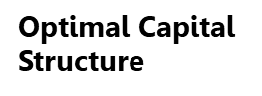
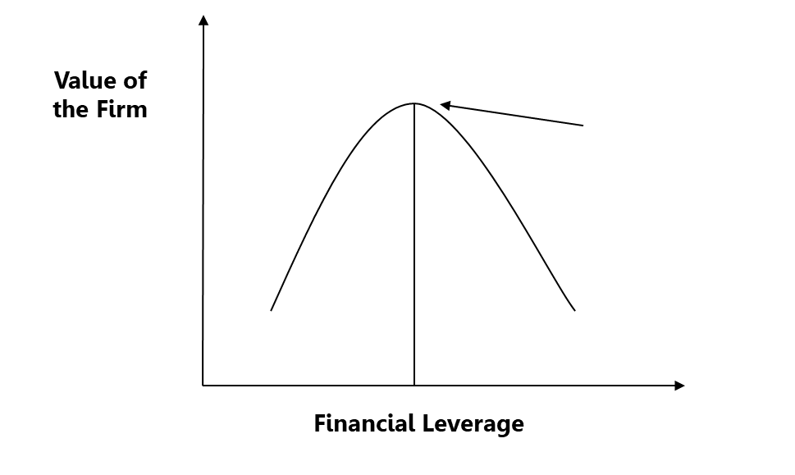

Understanding Optimal Capital Structure – Another Approach

The value of a firm can be calculated as the present value of the future cash flows a company generates for both its debt and equity investors and not just its common shareholders. The discount rate used is not the cost of equity but the company’s weighted average cost of capital (WACC). As the exhibit below shows, the value of the firm will be maximized when the WACC is minimized, so minimizing WACC is another way to determine a firm’s optimal capital structure.
Exhibit 4: Using Financial Leverage
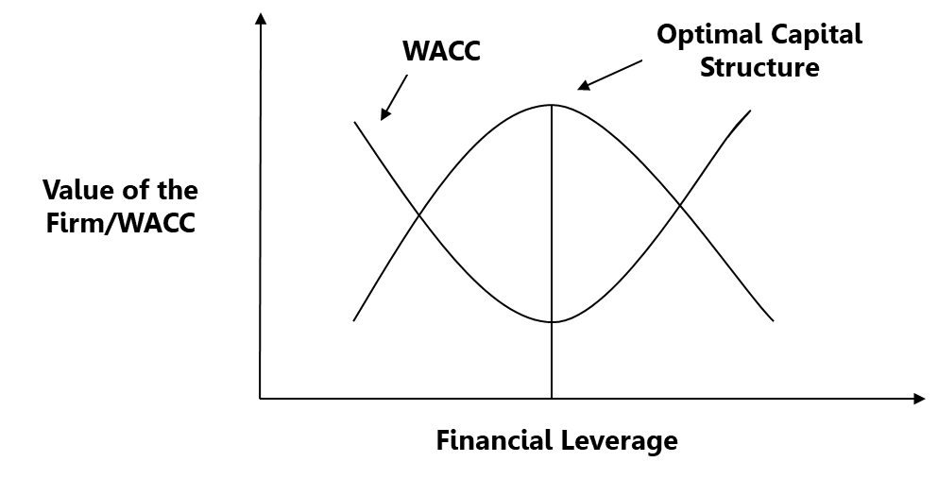

As discussed, WACC falls initially due to the substitution of cheaper debt for equity, but this is eventually countered by a higher k_{c} and k_{d} due to greater bankruptcy risk as shown in the following exhibit.

Exhibit 5: Optimal Capital Structure

Debt Ratio | k_{C} | After-tax k_{d} | WACC
0% | 10.50% | 5.00% | 10.50%
10% | 10.75% | 5.10% | 10.18%
20% | 11.00% | 5.30% | 9.86%
30% | 11.50% | 5.50% | 9.71%
40% | 12.00% | 5.80% | 9.50%
50% | 14.00% | 6.70% | 10.36%
60% | 16.20% | 7.80% | 11.15%
70% | 18.10% | 8.70% | 11.51%
Optimal capital structure
As a company moves from a debt ratio of 0% to 10%, the firm becomes riskier so k_{c} and k_{d} rise but only modestly as the risks of overborrowing are still quite low. WACC falls as the benefits from substituting lower-cost debt for more expensive equity are greater than the extra costs from a higher k_{c} and k_{d}. Progressing from a 20% to 30% to 40% debt ratio, the WACC continues to decline but at a slower rate as k_{c} and k_{d} begin to rise faster due to greater bankruptcy risk. Eventually, the costs from a rising k_{c} and k_{d} surpass any benefits from substituting cheaper debt for equity and WACC begins to rise. The debt ratio at this point is the firm’s optimal capital structure.

A company’s optimal capital structure is not a specific point but a range of points as the parabola is flat around the optimal point. It is also difficult to determine this point precisely due to uncertain inputs. As well, debt and equity capital are issued in large amounts at different times to economize on issuance costs and take advantage of changing market conditions so swings in a firm’s capital structure occur naturally.
1.2 | Business and Financial Risk

Business risk is the main determinant of optimal capital structure. It is defined as the underlying variability of a company’s operating profit (EBIT) which is determined by:

Sales risk. Incorporates factors that affect the variability of sales including the cyclical nature of the business, foreign exchange risk, random events such as strikes or new product launches, product diversification, the intensity of industry competition, rate of technological change, and product obsolescence, and growth prospects.

Operating risk. Includes factors that affect the variability of EBIT such as input cost changes and operating leverage. Operating leverage is the level of fixed versus variable operating costs in a company’s total cost structure. The more fixed costs a firm has, the greater the variability of its EBIT.

Firms are not going to use a lot of financial leverage or incur financial risk if they already have high variability of EBIT or business risk as it puts them in jeopardy of not being able to pay their interest and principal in a downturn. Alternatively, firms with lower business risk will borrow more. Degree of operating leverage (DOL) is a financial ratio that measures the presence of fixed operating costs in a firm’s total cost structure. The degree of financial leverage (DFL) measures the presence of fixed interest. The DOL and DFL should move in opposite directions if a company is acting responsibly. The degree of combined leverage (DCL) amalgamates the effects of operational and financial leverage and measures whether business and financial risk are being properly balanced.

Calculating the Degree of Operating Leverage

The exhibit below provides cost-volume-profit charts for two companies in the same industry. The main difference between the two firms is their total cost structure.

Exhibit 6: Differences in Total Cost Structure
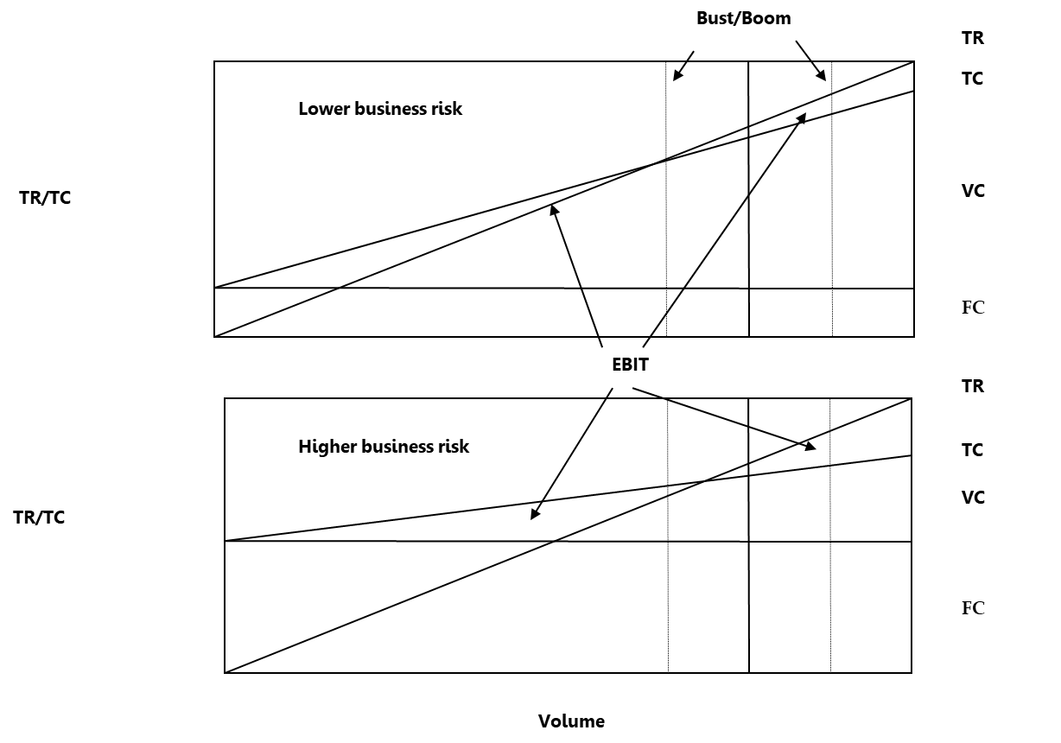

The darker vertical line is average sales volume, while the lighter vertical lines are sales during the low (i.e. bust) and high points (i.e. boom) in the business cycle. At the bottom of the cycle, the first company can breakeven while the second company experiences a loss due to its higher fixed costs. EBIT, which is the difference between total revenue (TR) and total cost (TC), rises as sales increase, but it rises faster at the second company with higher fixed costs. This is because the company’s TCs do not increase as fast as its TRs as they are largely fixed resulting in faster EBIT growth. The same logic applies as sales fall. The second company’s variable TRs fall faster than their largely fixed TCs causing EBIT to fall faster. As sales change over the business cycle, companies with higher fixed have greater variability of EBIT or business risk.

Again, DOL measures the presence of fixed operating costs in a firm’s total cost structure. DOL is calculated as:

DOL = Percent change in EBIT / Percent change in sales or contribution margin

A company’s contribution margin is its profit after variable costs. The percent change in sales and contribution margin are the same since the difference between the two amounts is variable costs that rise and fall at the same rate as sales. Theoretically, if a company has no FCs the percent change in EBIT and sales would be the same so the minimum DOL is 1.0. As a company’s FCs increase, the percent change in EBIT rises in comparison to the percent change in sales because of the greater FCs leading to a higher DOL. A higher DOL means a company has more FCs in its total cost structure and thus more business risk. DOL magnifies the percent change in sales (i.e. sales risk) yielding the percent change in EBIT (i.e. business risk).

(Percent change in sales or contribution margin) (DOL) = (Percent change in EBIT)

The DOL formula can be rearranged to:

DOL = Quantity (Price – Variable cost) / (Quantity (Price – Variable cost) – Fixed cost)

This formula is preferred because it uses data from one volume level only instead of determining the percent change between two volume levels. DOL is not stable but falls naturally as a firm’s sales increase because as TCs rise with higher sales, FCs remain the same and thus make up a smaller percentage of TCs which reduces operational leverage.

Calculating the Degree of Financial Leverage

The logic is the same for the DFL as the DOL except fixed interest replaces fixed operating costs. DFL is calculated as:

DFL = Percent change in EBT / Percent change in EBIT

This formula can be rearranged to:

DFL = (Quantity (Price – Variable cost) – Fixed cost) / (Quantity (Price – Variable cost) – Fixed costs – Interest)
DFL magnifies the percent change in EBIT (i.e. business risk) yielding the percent change in EBT.
(Percent change in sales) (DOL) = (Percent change in EBIT)

(Percent change in EBIT) (DFL) = (Percent change in EBT)

Calculating the Degree of Combined Leverage

DCL combines the effect of both fixed operating and interest costs. DCL is calculated as:

DCL = Percent change in EBT / Percent change in sales or contribution margin

DCL = DOL x DFL

DCL = Quantity (Price – Variable cost) / (Quantity (Price – Variable cost) – Fixed costs – Interest)

Management Implications

Business risk is largely industry-specific and outside the control of management. Auto manufacturers have high business risk because of their cyclical sales, intense industry competition, high rate of technological change, rapid new product development, and capital-intensive production processes leading to high fixed operating costs. Alternatively, grocery stores have much lower business risk due to their stable sales as they sell mostly necessities, fewer fixed costs as most of their capital is invested in inventory, limited technological change, and product development that is largely managed by their suppliers. Auto companies do limit their borrowing, but this is not always possible due to intense industry competition which has resulted in several high-profile bankruptcies over the last 40 years. Grocery stores use considerably more debt and generate consistent profits over the business cycle.

Despite this lack of control, there are still several actions firms can take to reduce business risk. These include:

- Turn fixed costs into variable costs by contracting out services such as call centers, information technology departments, or warehousing and delivery.
- Negotiate long-term supply contracts for labour and materials to lower input cost variability although this usually results in higher overall costs.
- Use less capital-intensive production processes such as 3-D printing.
- Hedge commodity prices and exchange rates using derivatives and other natural hedging strategies.

1.3 | Capital Structure Theories

Academics have developed several theories explaining how firms determine their optimal capital structure. These include:

Modigliani and Miller (MM) without taxes. This theory is divided into two propositions that ignore income taxes. Proposition I states that the unleveraged and leveraged values of a firm are the same, so the capital structure is irrelevant. This is true because regardless of how a firm is financed, the value of its assets is the same.
V_{u} =Value of the unleveraged firm
V_{L} = Value of the leveraged firm
EBIT = Earnings before interest and taxes
k_{e}u = Unleveraged required rate of return for equity
E = Market value of equity
D = Market value of debt

V_{U} = $\frac{EBIT}{k_{e}U}=$V_{L} = E + D

Proposition II calculates the required rate of return of the firm’s assets (k_{a}) or its WACC as:
k_{a} = ($\frac{E}{V} × k_{e})$ + ($\frac{D}{ V} × k_{d})$
It equals the weighted average cost of equity (k_{e}) and debt (k_{d}). V is the total market value of equity (E) and debt (D). The formula is rearranged to give:

k_{e} = k_{a} + (k_{a} – k_{d}) ($\frac{D}{E}$)

These two formulas and k_{d} are shown graphically below:

Exhibit 7: MM Without Taxes and Cost of Capital

k_{a} = WACC
Debt / Equity Ratio
Cost of Capital
k_{d}
k_{e}

Proposition II states the firm’s k_{a} or WACC is the same regardless of how it is financed. The benefits from using more lower-cost debt (k_{d}) are exactly offset by the higher cost of equity (k_{e}) due to greater financial risk. Again, a firm’s unleveraged and leveraged values are the same if WACC does not change, so its capital structure is irrelevant.

Modigliani and Miller (MM) with taxes. MM without taxes is unrealistic because interest is tax-deductible which lowers a firm’s cost of borrowing. If a company’s annual interest expenses were CAD 100 and its corporate tax rate (t) was 25%, it would receive a yearly tax benefit of CAD 25. The interest tax shield received in perpetuity is valued using the formula:

Present value of interest tax shield = $\frac{t × k_{d} × D }{k_{d}}$ = t × D

Proposition I states the value of an unleveraged and leveraged firm would equal:

V_{u} = $\frac{\left(EBIT\right)(1-t)}{k_{e}u}$

V_{L} = V_{U} + (t × D)

The formulas for k_{a} and k_{e} become:

k_{a} = ($\frac{E}{V} × k_{e})$ + ($\frac{D}{ V} × k_{d} ×(1-t)$)

k_{e} = k_{a} + (k_{a} – k_{d}) ($\frac{D}{E}$) (1 - $t)$

Proposition I and II say the value of the firm will continuously rise as debt financing increases and its k_{a} or WACC will fall. The optimal capital structure is at 100% debt financing as the benefits from using more debt are greater due to the interest tax shield than the increased cost of equity due to greater financial risk.

Exhibit 8: MM with Taxes and Value of the Firm

V_{U}
V_{L} = V_{U} + t × D
Debt
Firm Value
t × D

Exhibit 9: MM with Taxes and Cost of Capital
k_{a} = WACC
Debt / Equity Ratio
Cost of Capital
k_{d}
k_{e}

Modigliani won the 1985 Noble prize in economics for this theory and other work.

Static trade-off theory. MM with taxes states that financial leverage increases the value of a firm, but a major limitation of this theory is that it ignores bankruptcy costs. Incremental bankruptcy costs are initially quite low, but they grow rapidly as debt increases and eventually surpass the incremental benefits from borrowing. This crossover point approximates a firm’s optimal capital structure.

Exhibit 10: Static Trade-off Theory and Value of the Firm
V_{U}
V_{L} = V_{U} + t × D
Debt
Firm Value
Optimal capital structure
Bankruptcy costs
Interest tax shield
Maximum firm value
Actual firm value

The trade-off theory can also be explained in terms of WACC. As discussed, the value of a firm can be calculated as the present value of the future cash flows generated for both the company’s debt and equity investors instead of just the shareholders. The discount rate used to calculate the value of a firm is not the cost of equity but the company’s WACC. WACC falls initially due to the substitution of cheaper debt for more expensive equity, but this is eventually countered by a higher k_{c} and k_{d} due to greater bankruptcy costs. The value of the firm will be maximized when the WACC is minimized which is its optimal capital structure.

Exhibit 11: Static Trade-off Theory and Cost of Capital
WACC
Debt / Equity Ratio
Cost of Capital
k_{d} × ( 1 – t)
k_{e}
Optimal capital structure

Pecking order theory. Companies do not like to issue new common equity as it dilutes earnings per share (EPS), floatation costs are high compared to debt, and most managers think their shares are undervalued as investors are slow to recognize the company’s future potential. If funds are needed, retained earnings are used first, then debt, followed by preferred shares, and new equity as a last resort. Retained earnings are used first because they have no issuance costs and do not affect EPS. Debt and preferred shares have low issuance costs and are also less likely to be mispriced as their cash flows are set contractually unlike common shares. The pecking order theory states a company does not have an optimal capital structure, and its debt level depends on whether it has enough retained earnings to finance its growth. Debt ratios vary considerably as retained earnings rise and fall. Profitable companies borrow less because of more available funds. New equity issues are infrequent except for startups and during financial emergencies.

Financial slack and unused borrowing capacity. Businesses may have to refuse positive NPV projects because of a lack of funding. These firms maintain financial slack in the form of high cash balances and unused borrowing capacity to avoid lost investments, particularly in difficult times when profits and equity prices are depressed. This results in a capital structure that is below the optimal level.

Agency theory. Companies experience agency costs when managers do not work in the shareholders’ best interest and maximize the firm’s share price. Any retained earnings that are not needed to finance positive NPV projects should be paid out as dividends or stock repurchases. Instead, managers frequently spend these funds on higher executive compensation and perquisites such as corporate jets and personal chefs. They may also pursue “pet” projects with negative NPVs and make unprofitable business acquisitions as part of an empire-building strategy. To prevent these abuses, boards of directors may raise the firm’s debt level to eliminate any surplus cash and force management to operate the company more efficiently so it can service its debt obligations. But this strategy raises a company’s capital structure above its optimal point which exposes it to more risk during an economic downturn. The added risk may also discourage the company from pursuing positive NPV projects when they become available due to a lack of funds. A safer alternative is to improve corporate governance and executive compensation system to better align management and shareholder interests.

Corporate boards may also issue additional equity to dilute the ownership stake of outside groups attempting a takeover lowering a company’s capital structure below its optimal level.

Signaling theory. Investors do not have full information about a company due to imperfections in the capital markets. Managers are viewed by investors as having better information (i.e. asymmetric information) since they are business insiders. Investors assume rationale managers will only issue new common shares when they are overvalued to benefit existing shareholders. If managers have insider information about a company’s future initiatives that have not yet been made public, its shares will be undervalued so they will not issue new equity and instead raise debt. Once the information becomes public and the shares become overvalued, the company will issue new equity. As a result, share prices generally fall when new shares are issued as investors take this as a signal that the shares are overvalued.

Rational managers issue debt when rates are low to provide the most benefit to existing shareholders. Investors interpret debt issuances as a sign the firm is in good financial condition and can support additional borrowing so share prices rise. They also rise as investors believe debt is being used instead of equity because the share is currently undervalued but will rise in the future as new information about the company becomes available. Convertible debt is primarily used by growth firms who have bigger problems with asymmetric information to avoid the share price dilution caused by issuing undervalued shares now.

Signaling theory believes managers issue equity and debt to send a message to investors and not to achieve an optimal capital structure. This results in considerable variation in the firm’s capital structure. The asymmetric information problem is more important in rapidly growing and innovative industries where managers generally have much better information than the equity analysts who regularly follow the companies.

Market timing theory. A company’s share should always be fairly valued if financial markets are efficient. If managers do not agree with this premise, they will attempt to time the stock market to benefit their existing shareholders. They will sell company shares when they are overvalued and buy them back using stock repurchases when they are undervalued. This strategy is potentially very lucrative as managers can trade while in possession of insider information about the company. They are not guilty of insider trading as long as the firm follows regular corporate disclosure requirements and the managers do not trade on their personal accounts. Companies also time the debt markets by issuing debt when rates are low or temporarily issuing short-term debt if they expect long-term rates to fall. As with signaling theory, market timing causes considerable variation in a firm’s capital structure.

1.4 | Determining Optimal Capital Structure

Capital structure theories help understand the concept of optimal capital structure, but they are of limited value to practitioners in actually determining this point. Three more practical methods are:

Minimize WACC. Businesses can use historical company data to analyze the effect that varying debt-to-equity ratios have on the cost of debt and equity. The goal is to find the point where WACC is minimized and the value of the firm is maximized.

Industry average ratios. Firms adopt the industry-average capital structure assuming that companies in the same industry are comparable and have similar business and financial risk.

The long-term debt to total capitalization ratio and fixed charge coverage ratios are often used to measure a firm’s capital structure, but there are other ratios.

$$Long–term debt to total capitalization ratio= \frac{Long–term debt}{Long–term debt+Total equity}$$

$$Fixed charge coverage ratio= \frac{EBITDA+Lease expense}{Lease expense+Interest expense+ \frac{Preferred dividends }{(1-t)}+ \frac{Principal payments}{(1-t)}}$$

The long-term debt to total capitalization ratio measures what portion of a firm’s total capitalization is long-term debt. Total capitalization is the long-term debt and equity financing specifically raised to finance a company. Long-term debt includes interest-bearing long-term liabilities only plus the current portion of long-term debt. Short-term bank borrowing and other current and long-term liabilities like future income taxes or pension liabilities are excluded. The fixed charge coverage ratio improves on other coverage ratios by using EBITDA instead of EBIT as a proxy for cash flow from operations and by including other borrowing charges besides principal and interest including lease and preferred dividend payments on a before-tax basis.

The industry average approach is simple to apply but it has two major limitations. First, a business may adopt the industry-average capital structure, but the company may be quite different from the average firm. More variable sales, higher fixed costs, and lower profitability all reduce a company’s ability to borrow. Second, if all companies adopt the industry-average capital structure, then they are simply copying off each other and no firm is engaging in original analysis meaning the average ratio is unreliable. This problem is called circularity and it is particularly dangerous at the end of a long boom period when debt usage becomes excessive due to manager overconfidence. If no original analysis is done and all firms become over-leveraged, serious problems can result, especially in a severe economic slowdown.

Worst-case scenario. A company should only take on debt that it can support in a serious recession. If a business owner is not always ready for the worst-case scenario, they risk quickly losing a lifetime’s work – the 2008 financial crisis or the COVID-19 pandemic are recent examples. Pro forma financial statements are used to forecast sales and operating costs during this recessionary period to determine the amount of debt the company can likely support. Historical company and industry data from past recessions and other forecasts are used to estimate the parameters for this “what if” analysis or stress test. These might include the length of the initial slowdown and the subsequent recovery, the percent change in sales volume and prices each period, and any cost efficiencies such as workforce reductions or pay cuts that can be implemented.

Several practical considerations also influence how much a firm can borrow. These include:

Collateral. Liquid collateral such as marketable securities is easier to sell so financial institutions will lend more against it. General-purpose assets such as trucks have a more active secondary market compared to special-purpose items like industrial equipment. Tangible assets such as property, plant, and equipment have physical substance, so they are more valuable as collateral than intangible assets such as patents, copyrights, or brand names whose values are difficult to accurately estimate. Service companies with fewer fixed assets borrow less than capital-intensive firms.

Loan restrictions. Some lending agreements have maximum leverage ratio requirements that limit borrowing to safe levels. Bankers are primarily interested in protecting their loans and not maximizing a company’s share price so they may force firms to under-borrow.

No track record. New companies have a difficult time borrowing because of their limited business and financial track record. As businesses gain experience, their ability to secure debt financing grows.

Maintain a credit rating. Additional debt causes a company’s credit or bond rating to fall limiting its ability to access the credit markets. Businesses that issue debt publicly often establish a target credit rating and adjust their use of financial leverage to achieve this goal regardless of their optimal capital structure. Debt-to-equity ratios of companies in the same industry with similar bond ratings can be used as a guide. Credit rating agencies also give companies guidance as part of their assessment.

Exhibit 12: Financial Leverage by Bond Rating

 | AAA | AA | A | BBB | BB | B | CCC
Long-term debt to total capitalization | 13.3% | 28.2% | 33.9% | 42.5% | 57.2% | 69.7% | 68.8%

Control issues. Debt may be the only alternative for raising capital if issuing new equity causes the current owners to lose control of their business.

Management’s attitude towards risk. Some CEOs and CFOs are more aggressive in their use of financial leverage to increase a company’s short-term profits and their executive compensation especially if a company’s pay system does not carefully monitor excessive risk-taking.

Cultural differences. Countries such as Germany, Japan, and Korea are historically more dependent on bank financing as their equity markets are not as well developed as those in other countries such as the U.S. This can be traced back to the need for government-backed banks to help companies in these countries recover after WW II and the Korean War.

Institutional and economic differences. Businesses in developed countries with strong legal and financial regulatory systems including strong corporate governance guidelines, independent audit firms, and stock analysts use more equity and less debt as shareholders are better protected. Companies in inflationary countries use more equity and less debt because of the better inflation hedge provided by equities.

Tax status. Higher corporate tax rates encourage more borrowing because the after-tax cost of debt is lower. Unused loss carryforwards and low profitability discourage borrowing as the interest deduction is of no value if the company is not paying taxes.

Stock and bond market conditions. Academics normally calculate the debt-to-equity using the market value of equity and the book value of debt since it usually closely approximates market value. This makes it appear that there is considerable variation in the firm’s capital structure. Practitioners tend to use book value for both equity and debt to avoid this problem and do not engage in expensive debt/equity rebalancing to minimize transaction costs.

Takeover defenses. Excessive borrowing makes a company riskier and discourages takeovers by other firms. Executives may use this strategy to protect their jobs or help their shareholders realize the best takeover price possible.

State-owned or regulated enterprises. These organizations borrow more because governments do not want to invest a lot of equity due to their limited budgets but are willing to provide loan guarantees. Also, these enterprises are usually in more mature and less competitive industries which allows them to take on more debt than the average firm.

1.5 | Combining MM with Taxes and CAPM

MM with taxes states:
Formula 1 k_{e} = k_{a} + (k_{a} – k_{d}) ($\frac{D}{E}$) (1 - $t)$

An unleveraged or asset beta (B_{A}) measures the systematic risk of a firm’s assets which includes business risk but not financial risk. The k_{a} for an unleveraged firm is:

Formula 2 k_{a} = k_{f} + B_{a} (k_{m} – k_{f})

Assuming the firm’s debt has a beta of zero, the risk-free rate (k_{f}) can be substituted for k_{d} in formula 1. Formula 2 can also be substituted for k_{a} in formula 1 and then the formula can be rearranged.

k_{e} = k_{f} + B_{A} (k_{m} – k_{f}) + kr_{f} + B_{a} (k_{m} – k_{f}) – k_{f}) ($\frac{D}{E}$) (1 - $t)$

k_{e} = k_{f} + (k_{m} – k_{f}) (B_{a}) ($1+( \frac{D}{E} )$ (1 - $t))$
This formula shows that:

B_{e} = B_{a} ($1+( \frac{D}{E}$) (1 - $t))$ or B_{L} = B_{U} ($1+( \frac{D}{E}$) (1 - $t)$) or B_{L} = (B_{U} + B_{U}$( \frac{D}{E}$) (1 - $t)$)

The second variation of this formula was used in Module: Cost of Capital to determine the effect a change in capital structure would have on a firm’s leveraged beta. The third variation shows that the leveraged beta (B_{L}) is a function of a firm’s business risk (B_{U}) and its financial risk (B_{U}$( \frac{D}{E}$) (1 - $t)$). These formulas assume the debt’s beta is zero, but if a company is experiencing financial distress, the debt’s beta will rise above zero as it becomes uncertain whether investors will receive the interest and principal payments promised. Alternative formulas are available if this occurs, but debt has a beta of zero in most instances.

1.6 | Optimal Capital Structure at a Canadian Company

Optimal Capital Structure in Practice

Whether companies maximize shareholder value by closely adhering to an optimal capital structure or follow other policies is an area of considerable research as this greatly affects corporate returns and economic efficiency. A recent study¹ of Canadian businesses found that 65% of firms had adopted a target or optimal capital structure which was followed “tightly” by 12% of them, “somewhat tightly” by 53%, and “flexibly” by 35%. A higher proportion of small companies were also found to act flexibly.

A similar U.S. study² found that 81% of firms had a target capital structure and 10% had a “very strict target,” 34% had a “somewhat restrict target,” 37% had a “flexible target,” and 19% had no target. Again, a higher proportion of small companies were also found to act flexibly. The study also surveyed CFOs to determine what factors are “important” or very important” when deciding to issue debt or equity.

Exhibit 13: Factors Influencing Debt Issuance

Factor | Rationale
Financial flexibility (59%) | Keep unused borrowing capacity to finance possible future expansions and acquisitions
Credit rating (57%) | Maintain a target credit rating to ensure access to the financial markets which is especially important for larger, investment-grade companies
Earnings and cash flow variability (48%) | Firms with high business risk borrow less
Insufficient internal funds (47%) | Retained earnings are used first, then debt and new shares are issued as the last option according to the pecking order theory
Level of interest rates (46%) | Issue debt when rates are low according to the marketing timing theory
Interest tax savings (45%) | Take advantage of the interest tax shield according to the static trade-off theory
Transaction costs or fees (35%) | Take advantage of low debt issuance costs according to the static trade-off theory
Equity undervaluation/overvaluation (31%) | Issue shares when they are overvalued and issue debt or repurchase shares when they are undervalued according to the marketing timing theory
Comparable firm debt levels (24%) | Industry average leverage ratios are used to determine the optimal capital structure
Bankruptcy/distress costs (22%) | Bankruptcy costs are balanced against the interest tax shield according to the static trade-off theory
Customer/supplier comfort (19%) | Customers and suppliers avoid overleveraged firms with high indirect bankruptcy costs because of supply chain uncertainties
Change in stock price (16%) | Debt issuances cause share prices to rise as investors interpret this as a sign of business confidence and that its shares are undervalued according to the signaling theory

Exhibit 14: Factors Influencing Equity Issuance

Factor | Rationale
Earnings per share dilution (69%) | Issuing shares dilutes earnings per share so they are the last resort for raising capital according to the pecking order theory
Magnitude of equity undervaluation/ overvaluation (68%) | Issue shares when they are overvalued and issue debt or repurchase shares when they are undervalued according to the marketing timing theory
If recent stock price increase, selling price “high” (63%) | Issue shares when they are overvalued and issue debt or repurchase shares when they are undervalued according to the marketing timing theory
Providing shares to employee bonus/option plans (53%) | An equal number of stock repurchases are made when the shares are undervalued to meet these obligations and avoid EPS dilution according to the market timing theory
Maintaining a target debt/equity ratio (52%) | Bankruptcy costs are balanced with the interest tax shield according to the static trade-off theory
Diluting holdings of certain shareholders (50%) | Issue additional equity to dilute the ownership stake of outside groups attempting a takeover according to the agency theory
Stock is our “least risky” source of funds (30%) | Firms with high business risk borrow issue more equity
Sufficiency of recent profits to fund activities (30%) | Retained earnings are used first, then debt and new shares are issued as the last option according to the pecking order theory
A similar amount of equity as same-industry firms (22%) | Industry average leverage ratios are used to determine the optimal capital structure
Favorable investor impression versus issuing debt (21%) | Bankruptcy costs are balanced with the interest tax shield according to the static trade-off theory
No other sources of funds available (16%) | Retained earnings are used first, then debt and new shares are issued as the last option according to the pecking order theory

These results support the trade-off theory, but the finding that companies loosely adhere to their targets may support a dynamic instead of a static trade-off theory. A static theory explains that companies have a target optimal capital structure that balances the benefits of tax-deductible interest with bankruptcy costs, but other theories explain the significant variation in the capital structure around the target and why some firms are consistently over or under leveraged.

This research also indicates that the financial slack and unused borrowing capacity, market timing, and pecking order theories are more relevant in explaining the significant variation in the capital structure than the signaling and agency cost theories. Many firms, particularly growth companies, have financial slack and unused borrowing capacity so they can always pursue investment opportunities when they arise. If stocks experience a large run-up in value and debt-to-equity ratios fall, companies tend to issue equity to take advantage of higher share prices instead of issuing debt to return the firm to its target capital structure. Stock repurchases and debt issuances normally occur when stock prices and interest rates are low. Mature firms issue few common shares and instead rely on retained earnings, while growth firms issue new shares more often as they have less retained earnings and more quickly reach their borrowing limits especially if their collateral consists of primarily intangible asset

___________________________________

¹Baker, H., Dutta, S., Saadi, S. (2011). Corporate Finance Practices in Canada: Where Do We Stand? Multinational Finance Journal, vol. 15, no. 3/4, 157-192.

²Graham, J., Harvey, C. (2001). How Do CFOs Make Capital Budgeting and Capital Structure Decisions? Journal of Applied Corporate Finance, vol. 15, no. 1, 8-23.

